Analysis of birthweights
We have data on birthweights from Hosmer, Lemeshow, and Sturdivant(2013, 24). This dataset includes some demographic information on each infant's mother, such as her age and race. We also have relevant medical history, including her weight, history of hypertension and premature labor, and the number of physician visits during her first trimester.
Descriptive Statistics
Variable | Obs | Mean | Std. Dev. | Min | Max
bwt | 189 | 2944.286 | 729.016 | 709 | 4990

We have the recorded weight for 189 babies with an average birthweight of 2944.29 grams. There are 189 mothers who smoked during pregnancy, and 115 who did not. Below we graph the mean birthweight for babies with mothers who smoke versus those who do not, separately for mothers with and without a history of hypertension.
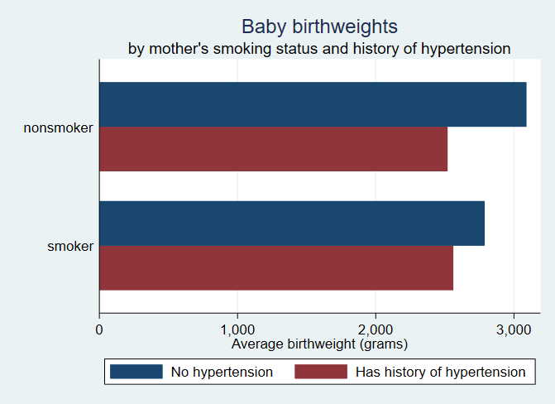Below, we fit a linear regression of birthweight on the mother's age and whether she smokes.

Linear regression
bwt | Coef. | St.Err. | t-value | p-value | [95% Co | Interval] | Sig
0b.smoke | 0
1.smoke | -277.292 | 106.98 | -2.59 | 0.01 | -488.341 | -66.242 | **
age | 11.179 | 9.881 | 1.13 | 0.259 | -8.314 | 30.671
Constant | 2793.083 | 240.934 | 11.59 | 0 | 2317.77 | 3268.397 | ***
Mean dependent var |  | 2944.286 |  | SD dependent var |  |  | 729.016
R-squared |  | 0.043 |  | Number of obs |  |  | 189.000
F-test |  | 4.137 |  | Prob > F |  |  | 0.017
Akaike crit. (AIC) |  | 3024.790 |  | Bayesian crit. (BIC) |  |  | 3034.516
Notes: *** p<.01, ** p<.05, * p<.1

We find that on average, infants whose mothers smoked tend to weigh less, and the mother's age is not a statistically significant factor.

