Example of using a pie graph in asdocx
Figure 1. Pie graph example using scheme cleanplots (Mize 2021).
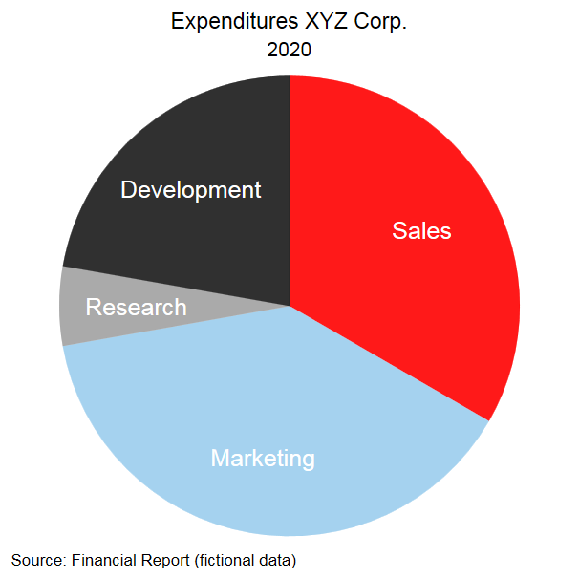
Figure 2. Pie graph example using own colors.
